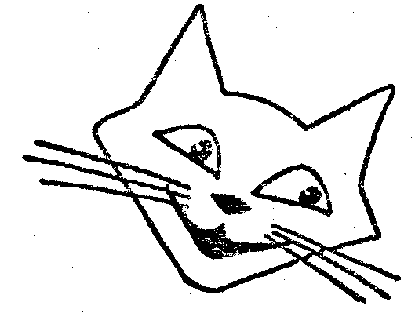INVITATION
The Kentish Cat Society
GARDEN PARTY
will be held on Sunday 6th July 2025
Starting at 3 pm at
Tickets just £3 / person.

Spookeys, 65, Sidney Gardens, Otford, Sevenoaks, Kent. TN14 5PX

We shallbe the guests of Committee member Barbara Darby, for our garden party. You don’t have to be a member of the Society to come.This is a chance to make new friends and enjoy unlimited cat chat. Whatever the weather our garden parties are great fun, the highlight of the event will be an excellent tea, this year with sandwiches, cake, nibbles and soft drinks.
There will also be a raffle, for which all contributions are welcome. There will also be a collection of tins of food and towels for cats less fortunate than all of ours.

As we don’t have many chairs, please bring something to sit on for your comfort.
Book your tickets now and in any case not later than 30th June please to allow for catering arrangements.

See reverse for contact and payment details.

Please complete and reply:

To: Mrs H Nicholson(Hon Secretary KCS), 15, Eynsford Road, Farningham, Kent DA4 0BD email: kcs@metallicat.com
Please book me places for the garden party on 6th July 2025 at £3.00 each.
I enclose a cheque (payable to the Kentish Cat Society) for £ .
You can pay by BAC
Account Name :The Kentish Cat Society
Sort Code: 30-99-50
Account Number: 58553360
Please include the reference GP your surname & first 3 letters of your postcode so we can link you payment to you.
Name & address

Tel:

